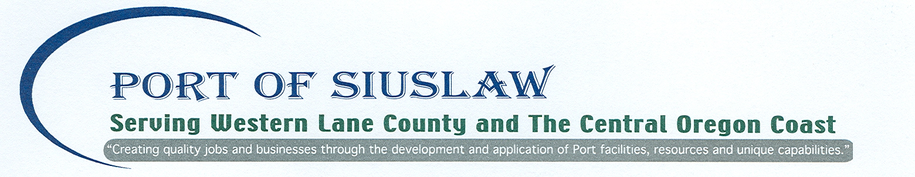

Request for Proposal
Replace North and South Signboards Between Upper Roof Structures
On Mo’s Restaurant
August 29, 2018

The Port of Siuslaw is requesting proposals to perform repairs on Mo’s Restaurant, located at 1436 Bay Street, Florence, Oregon, on the Port of Siuslaw Wharf.

The project is to be completed during fall/winter of 2018, with all work finished by December 15, 2018.

General Requirements:
- All work must be done in accordance with OSHA requirements.
- All paint must be Pittsburgh Paints/Weather King Exterior, semi-gloss body and trim.
- Color to match existing color as close as possible.
- One coat of primer and two coats of top will be applied unless otherwise noted in following specifications.
- All fasteners and flashing to be stainless steel.
- All cut or bare wood edges and ends to be primed.
- Port of Siuslaw to be responsible for permits.
- Daily cleanup and removal of debris is responsibility of the contractor.

- Salem Sign will isolate electrical services to north and south neon signs between upper roof structures on Mo’s building. Salem Sign will remove, store, and reinstall neon signs following construction of sign boards. Contractor will work with Salem Sign to coordinate timing of removal and reinstallation of neon signs.
- Remove north and south signboards between upper roof structures.
- Build new signboards to match old signboard’s structure and design using pressure treated structural framing and plywood. New signboards must be built to meet the existing size dimensions and existing trim and backing. Install same.
- All metal to be stainless steel, including flashing and structural brackets.
- Attachment to roof areas to be flashed as required.
- Use of lifts and cranes will be at the discretion of the contractor.
- Contractor to include work and costs associated with any other sub-contractors such as electrical and painting.
- Painting of pressure treated plywood on the interior side of the signs are not needed.
- Prime and paint all new wood other than interior pressure treated plywood
- Work to be done in a workmanlike manner.
- Port will be responsible for all other work on the inside of the upper roof structure including siding and trim repair to roof structures and doors.
- Selected contractor will make note of existing structural and roofing components to insure proposed work does not adversely affect existing roofing and other building related components.

The successful proposal will be selected based on: quality of work; relevant experience; references; ability to meet schedule; familiarity with Port of Siuslaw facilities; and proposal price.

Successful bidder will provide certification of nondiscrimination in obtaining required subcontractors in accordance with ORS 279A.110 (4).

Successful bidder will provide Performance and Payment Bonds.

Respondents wishing to protest should follow Protest Procedures as found in Oregon Public Contracting Rules, Chapter 37, Division 47, 137-047-0730 and -0740.

The Port of Siuslaw may cancel this procurement or reject any or all proposals in accordance with ORS 279B.100.

The proposals are due at the Port Office by Friday, 5:00 pm, September 14, 2018.
Proposals may be submitted via mail, email, fax, or in person.

For complete information on this project, contact Jason Wagner, 100 Harbor Street, Florence, Oregon 97439, (541) 999-1256, Jason@portofsiuslaw.com, Fax 541-997-9407.

